Exercise No : 4

Date : 14/10/2020

**AIM:**

To print a single string from two set of strings received from user and swap the first two characters of each string.

**PROGRAM:**

def swap(s):

new = " "

for x in s:

new += x

return new

a = input("enter the first string: ")

b = input("enter the second string: ")

s1 = a.strip()

s2 = b.strip()

if(len(s1)>=2 and len(s2)>=2):

t1 = list(s1)

t2 = list(s2)

c1 = t1[0]

c2 = t1[1]

t1[0] = t2[0]

t1[1] = t2[1]

t2[0] = c1

t2[1] = c2

s1 = swap(t1)

s2 = swap(t2)

print(s1," ",s2)

else:

print("Invalid")

**LINK:**

http://103.53.53.18/mod/vpl/forms/edit.php?id=234&userid=1639

**OUTPUT:**

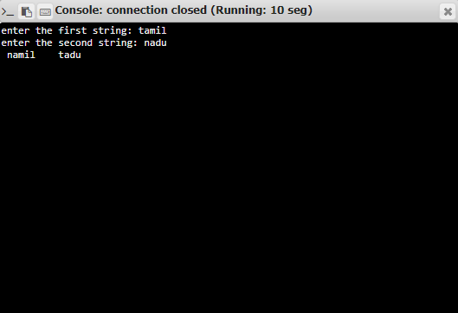

**RESULT:**

The program has been successfully executed and verified.